1.Create a simple calculator in python

def add(num1, num2):

return num1 + num2

def subtract(num1, num2):

return num1 - num2

def multiply(num1, num2):

return num1 * num2

def divide(num1, num2):

if num2 != 0:

return num1 / num2

else:

return "Error: Cannot divide by zero"

print("Simple Calculator")

print("------------------")

while True:

print("Select operation:")

print("1. Add")

print("2. Subtract")

print("3. Multiply")

print("4. Divide")

print("5. Exit")

choice = input("Enter your choice (1-5): ")

if choice == '5':

print("Exiting the calculator...")

break

num1 = float(input("Enter the first number: "))

num2 = float(input("Enter the second number: "))

if choice == '1':

print("Result:", add(num1, num2))

elif choice == '2':

print("Result:", subtract(num1, num2))

elif choice == '3':

print("Result:", multiply(num1, num2))

elif choice == '4':

print("Result:", divide(num1, num2))

else:

print("Invalid input. Please try again.")

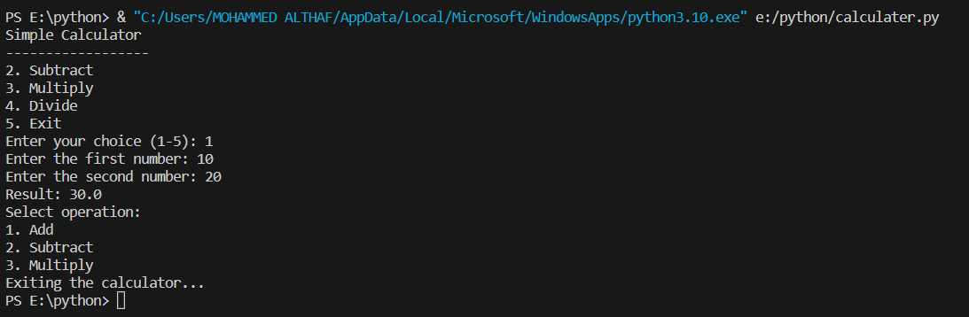

2. An electric power distribution company charges domestic customers as follows:

Consumption unit Rate of charge:

● 0-200 Rs .0.50 per unit.

● 201-400 Rs. 0.65 per unit in excess of 200.

● 401-600 Rs 0.80 per unit in excess of 400.

● 601 and above Rs 1.00 per unit in excess of 600.

● If the bill exceeds Rs. 400, then a surcharge of 15% will be charged, and

the minimum bill should be Rs. 100/-

Create a python program based on the scenario mentioned above.

def calculate_bill(units):

    total_bill = 0

    if units <= 200:

        total_bill = units * 0.50

    elif units <= 400:

        total_bill = 200 * 0.50 + (units - 200) * 0.65

    elif units <= 600:

        total_bill = 200 * 0.50 + 200 * 0.65 + (units - 400) * 0.80

    else:

        total_bill = 200 * 0.50 + 200 * 0.65 + 200 * 0.80 + (units - 600) * 1.00

    if total_bill > 400:

        surcharge = total_bill * 0.15

        total_bill += surcharge

    if total_bill < 100:

        total_bill = 100

    return total_bill

units_consumed = int(input("Enter the number of units consumed: "))

bill_amount = calculate_bill(units_consumed)

print("Electricity Bill: Rs.", bill_amount)

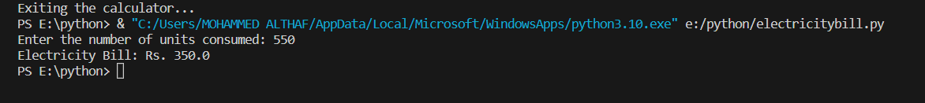

3.Print the Pyramid of numbers using for loops.

rows = int(input("Enter the number of rows: "))

for i in range(1, rows + 1):

for j in range(1, rows - i + 1):

print(" ", end="")

for j in range(1, i + 1):

print(j, end="")

for j in range(i - 1, 0, -1):

print(j, end="")

print()

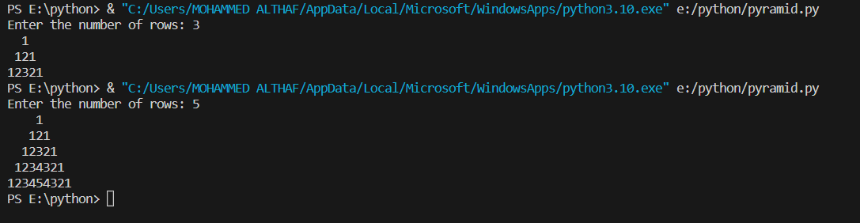

4.Write a program to find the number of and sum of all integers greater than 100 and less than 200 that are divisible by 7.

count = 0

sum = 0

for num in range(101, 200):

if num % 7 == 0:

count += 1

sum += num

print("Number of integers divisible by 7:", count)

print("Sum of integers divisible by 7:", sum)



5. Write a recursive function to calculate the sum of numbers from 0 to 10

def calculate_sum(n):

if n == 0:

return 0

else:

return n + calculate_sum(n - 1)

result = calculate_sum(10)

print("Sum of numbers from 0 to 10:", result)



6.Write a Python program to reverse the digits of a given number and add it to the original, If the sum is not a palindrome repeat this procedure.

def reverse_number(n):

    return int(str(n)[::-1])

def is_palindrome(n):

    return str(n) == str(n)[::-1]

def reverse_and_add(n):

    while not is_palindrome(n):

        reverse = reverse_number(n)

        n += reverse

        print(n)

    return n

number = int(input("Enter a number: "))

result = reverse_and_add(number)

print("Palindrome sum:", result)

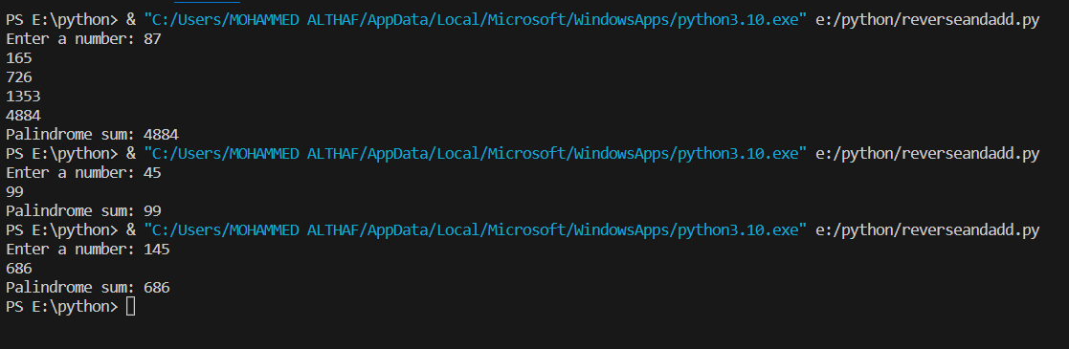

7. Write a menu-driven program that performs the following operations on

strings

A) Check String is Substring of Another String

B) Count Occurrences of Character

C) Replace a substring with another substring

D) Convert to Capital Letters

def check_substring():

    main_string = input("Enter the main string: ")

    substring = input("Enter the substring to check: ")

    if substring in main_string:

        print(f"'{substring}' is a substring of '{main_string}'.")

    else:

        print(f"'{substring}' is not a substring of '{main_string}'.")

def count_occurrences():

    main_string = input("Enter the main string: ")

    char = input("Enter the character to count: ")

    count = main_string.count(char)

    print(f"The character '{char}' occurs {count} times in '{main_string}'.")

def replace_substring():

    main_string = input("Enter the main string: ")

    old_substring = input("Enter the substring to replace: ")

    new_substring = input("Enter the new substring: ")

    new_string = main_string.replace(old_substring, new_substring)

    print("New string:", new_string)

def convert_to_capital():

    main_string = input("Enter the main string: ")

    capitalized_string = main_string.upper()

    print("Capitalized string:", capitalized_string)

while True:

    print("\nMenu:")

    print("A) Check String is Substring of Another String")

    print("B) Count Occurrences of Character")

    print("C) Replace a substring with another substring")

    print("D) Convert to Capital Letters")

    print("E) Exit")

    choice = input("Enter your choice (A/B/C/D/E): ")

    if choice == "A":

        check_substring()

    elif choice == "B":

        count_occurrences()

    elif choice == "C":

        replace_substring()

    elif choice == "D":

        convert_to_capital()

    elif choice == "E":

        print("Exiting the program...")

        break

    else:

        print("Invalid choice. Please try again.")

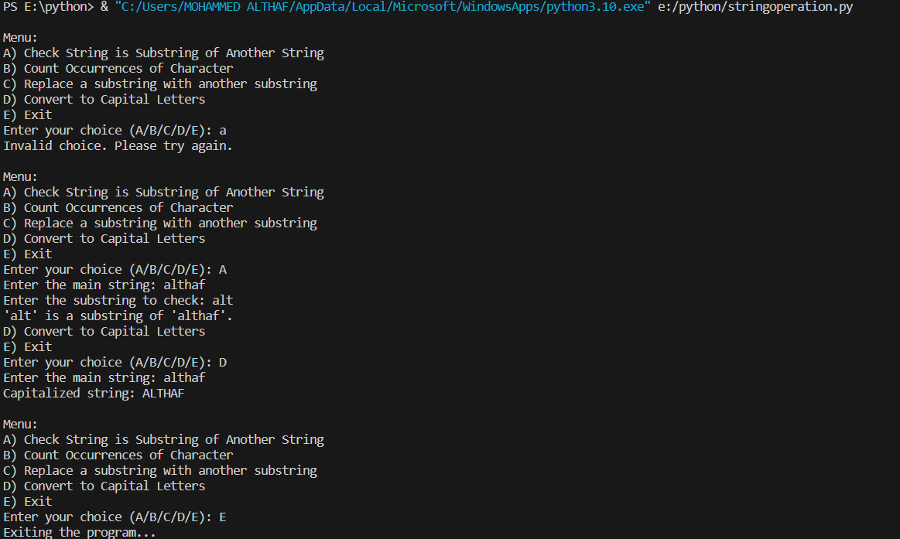

8. Write a function to find the factorial of a number but also store the factorials

calculated in a dictionary.

factorial_dict = {}

def factorial(n):

    if n < 0:

        raise ValueError("Factorial is not defined for negative numbers.")

    if n in factorial_dict:

        return factorial_dict[n]

    elif n == 0 or n == 1:

        factorial_dict[n] = 1

        return 1

    else:

        result = 1

        for i in range(2, n + 1):

            result *= i

            factorial_dict[i] = result

        return result

num = int(input("Enter a number: "))

result = factorial(num)

print(f"The factorial of {num} is {result}.")

print(factorial_dict)



9.Perform various set operations

A) Set Union

B) Set Intersection

C) Set Difference

set_A = {1, 2, 3, 4, 5}

set_B = {4, 5, 6, 7, 8}

union_set = set_A.union(set_B)

print("Set Union:", union_set)

intersection_set = set_A.intersection(set_B)

print("Set Intersection:", intersection_set)

difference_set = set_A.difference(set_B)

print("Set Difference (A - B):", difference_set)



10. Create a dictionary to store the name, roll_no, total_mark of N students. Now

print the details of the student who has got the highest total_mark.

N = int(input("Enter the number of students: "))

student_dict = {}

for i in range(N):

    name = input("Enter student name: ")

    roll_no = input("Enter roll number: ")

    total_mark = float(input("Enter total marks: "))

    student_dict[roll_no] = {'Name': name, 'Total Marks': total_mark}

highest_marks = 0

highest_marks_student = None

for roll_no, details in student_dict.items():

    if details['Total Marks'] > highest_marks:

        highest_marks = details['Total Marks']

        highest_marks_student = details

print("\nStudent with the highest total marks:")

print("Name:", highest_marks_student['Name'])

print("Roll No:", list(student_dict.keys())[list(student_dict.values()).index(highest_marks_student)])

print("Total Marks:", highest_marks)

